**HEXADECIMAL TO DECIMAL**  
  
**AIM:**To write an assembly language program to implement prime number using 8085 processor.  
**ALGORITHM:**  
1)   Start the program by loading a register pair with address of 1st number.  
2)   Copy the data to another register pair.  
3)    Load the second number to first register pair.  
4)    Subtract the two register pair contents.  
5)    Check for borrow.  
6)    Store the value of difference and borrow in memory locations.  
7)    End.   
**PROGRAM:**

LXI H,8000H

MVI D,00H

XRA A

MOV C, M

LOOP: ADI 01H

DAA

JNC SKIP

INR D

SKIP: DCR C

JNZ LOOP

MOV L, A

MOV H, D

SHLD 8050H

HLT

INPUT:

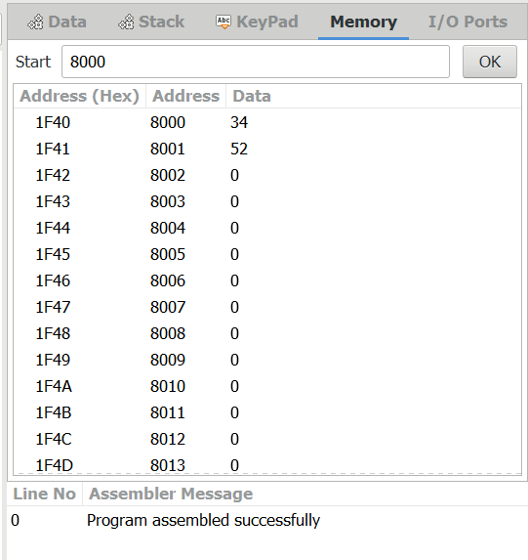

OUTPUT:

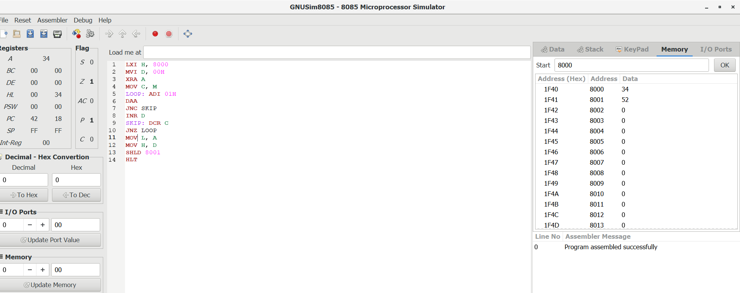

RESULT:

Thus the program was executed successfully using 8085 processor.